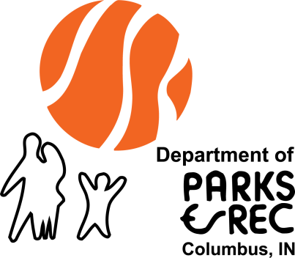

**Parks and Recreation Department**

**C:\Program Files\Microsoft Office\MEDIA\OFFICE14\Lines\j0115876.gif2017 Annual Report**

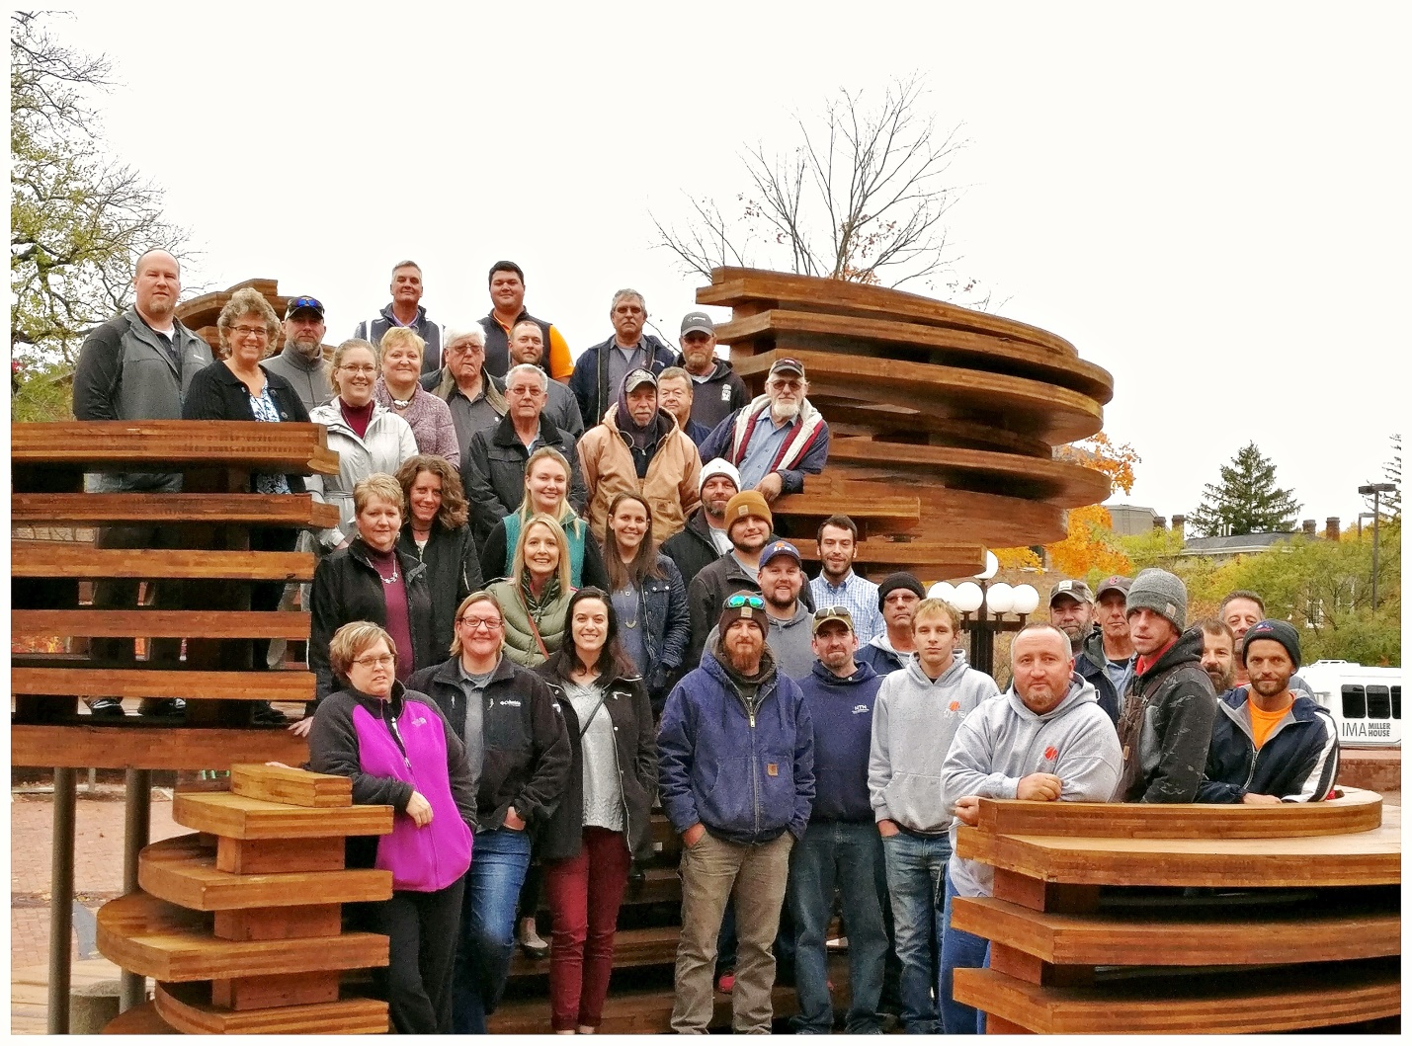

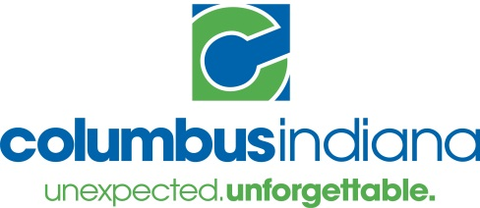

Table of Contents

Department Overview 3

Executive Summary 3

Vision Statement 3

Parks and Recreation Staff 3

Parks and Recreation Board 4

Organizational Chart 6

Programs and Major Accomplishments 7

Athletics 7

Athletic Facilities 7

Columbus Dog Park 8

Columbus Gymnastics Center 8

Donner Aquatic Center 9

Golf Courses 10

Hamilton Community Center & Ice Arena 10

Park Operations 11

Recreation & Special Events 12

The Commons 13

The Columbus Park Foundation 13

Current Projects 14

Goals for Fiscal Year 2018 15

Budget and Financials 15

2017 Budget 15

Financials 18

Parks General Fund 18

Parks Non-Reverting Fund 18

The Commons Fund 19

Addendum 20

Athletics 20

Columbus Gymnastics Center 20

Donner Aquatic Center 21

Golf Courses 21

Hamilton Community Center & Ice Arena 22

Recreation and Special Events 23

The Commons 24

# Department Overview

## Executive Summary

In 2017, the Columbus Parks and Recreation Department celebrated a number of very significant milestones.  We celebrated the 100th anniversary of the donation of Donner Park to the City of Columbus, the 25th Anniversary of Mill Race Park and our Parks Department turned 70!  Thoughtful development of our parks, facilities and programs have gotten us where we are today.  With the Park Board adopting our new 5-year comprehensive Master Plan and the continued support from our citizens, local government and the private sector, we will continue to provide high quality facilities and programs to our community.  Parks not only make our community stronger, they also make our lives better.  Our Department takes a lot of pride in contributing to improved physical and mental health, economic vitality, community safety and so much more.  This is the Power of Parks!  In the pages that follow, our Department highlights our wonderful accomplishments of 2017.  Thank you for supporting Columbus Parks and Recreation Department as we work to fulfill our mission of, “Enriching Lives….Building Community.”  We look forward to an even more successful and exciting 2018!

## Vision Statement

The Columbus Parks and Recreation Department

* Is recognized on a local, state and national basis for providing the highest quality programs and facilities;
* Has a well-trained, friendly and professional staff that is proud to serve the community;
* Anticipates and is responsive to the changing needs and desires of our community;
* Is an active participant in a community-wide program successfully promoting healthy lifestyles and wise leisure choices;
* Is identified as the clearinghouse in Columbus & Bartholomew County for fun activities for children and families;
* Is a major partner in tourism and economic development through the development of park amenities that host and attract visitors to regional and national sports and cultural events.

## Parks and Recreation Staff

*Director of Parks and Recreation*, Mark Jones  
*Director of Business Services*, Pam Harrell  
*Director of Park Operations*, Casey Ritz  
*Project & Resource Development Director*, Stacy Findley   
*Director of Sports Programs*, Nikki Murphy  
*Administrative Assistant*, Jessica Prowant *The Commons Manager*, Shanda Sasse  
*Aquatics Director*, Jim Lemke  
*Recreation & Columbus Gymnastics Center Program Manager*, Kathy McPeek  
*Athletic Facilities Supervisor*, Travis Tindell  
*Marketing Coordinator*, Carley Freeman  
*Sports Coordinator*, Patrick Senn  
*Hamilton Community Center & Ice Arena Manager*, Carleen Fry  
*Golf Pro/Manager*, Keith VanDeventer  
*Assistant Recreation & Columbus Gymnastics Center Program Manager*, Lisa McDaniel  
*Payroll/HR Specialist*, Tonia Medaris  
*Accounts Payable Specialist*, Crystal Martinez  
*Customer Service Specialist*, Mary Scheidt  
*Park Operations Administrative Assistant*, Lori Hedrick  
*The Commons Administrative Assistant*, Terre Schwartzkopf  
*CGC/FFY Customer Service/Registration Manager*, Denise Davis  
*Hamilton Community Center & Ice Arena Customer Service Specialist*, Lauren Lafferty

## Parks and Recreation Board

President Columbus Park Board, Mark Levett  
Vice President Columbus Park Board, Julie Abedian  
Secretary Columbus Park Board, Milly Maier  
Member Columbus Park Board, John McCormick

Meetings of the Columbus Park Board are normally held on the second Thursday of each month beginning at 4:00 p.m. in Council Chambers at City Hall.

* January 5, 2017 (rescheduled from January 12)
* February 9, 2017
* March 9, 2017 (rescheduled to March 16 and then cancelled due to no quorum)
* April 13, 2017
* May 11, 2017
* June 8, 2017
* July 13, 2017
* August 10, 2017
* September 14, 2017
* October 12, 2017
* November 9, 2017
* December 14, 2017

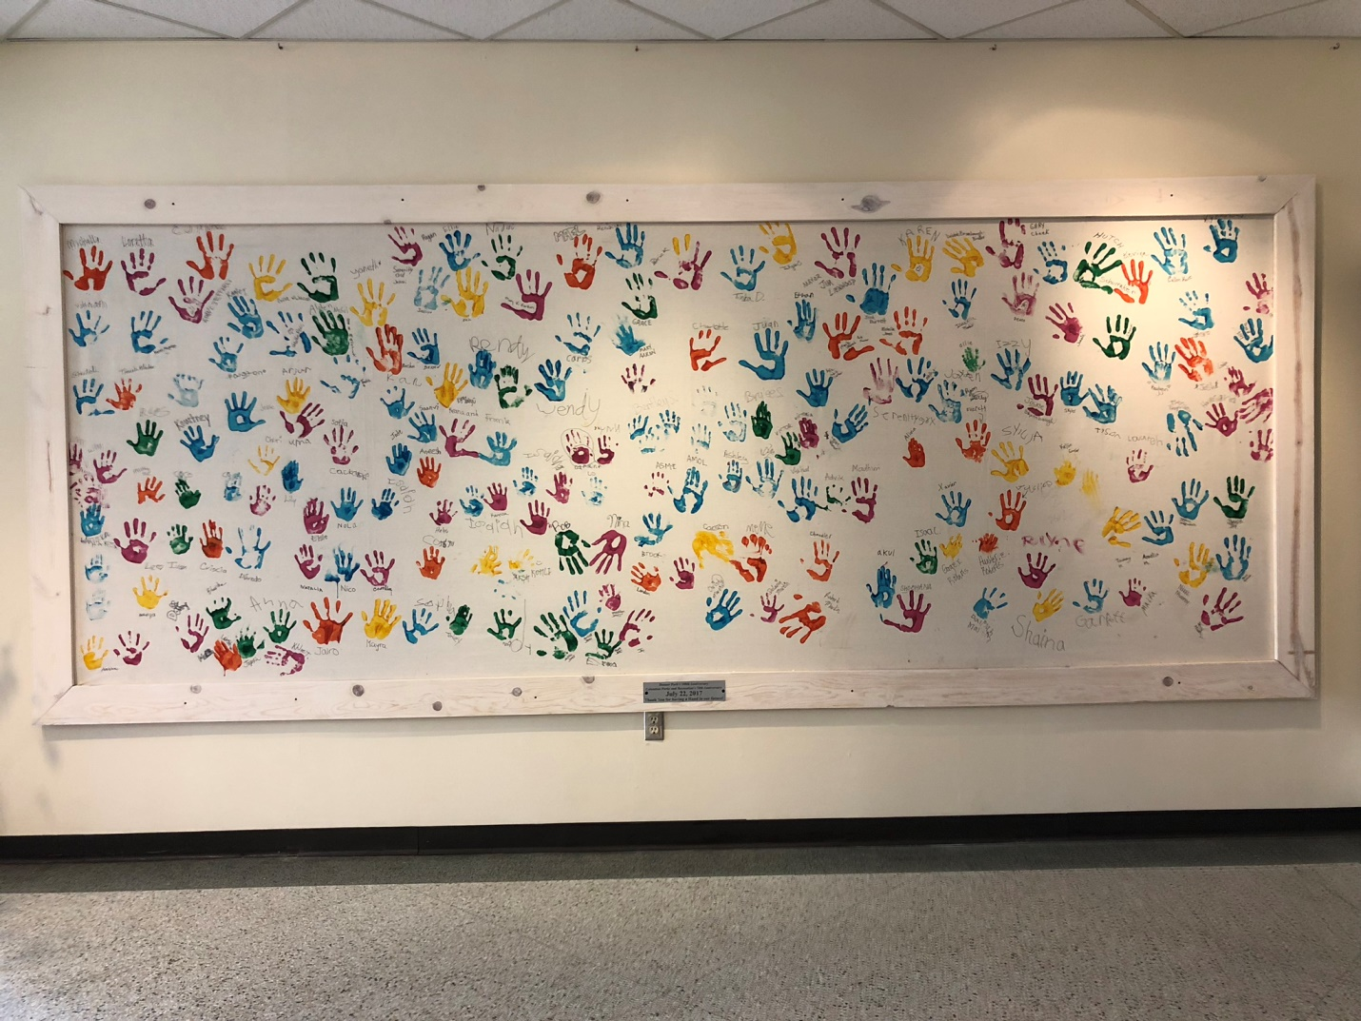  
 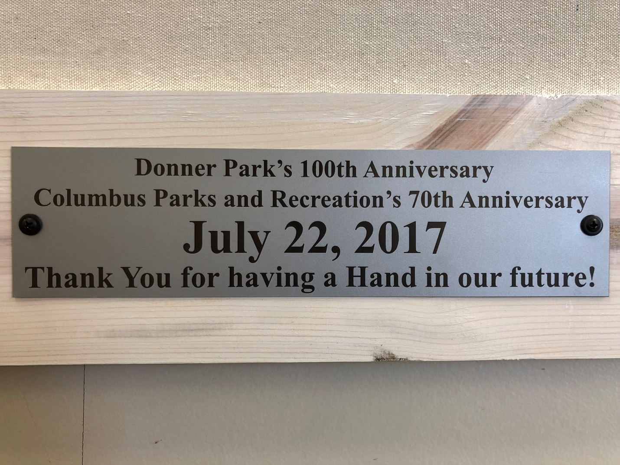

## Organizational Chart



# Programs and Major Accomplishments

## Athletics

Athletics encompasses a lot of different programs and facilities within the Parks Department. In addition to programs, we oversee the facility and grounds maintenance of Clifty Park diamonds, Lincoln Park diamonds and batting cages, Donner and Lincoln tennis courts, and the Blackwell Park and Richard Wigh Soccer Complex fields and facilities. That facility maintenance helps to provide support for all of the recreational sports we offer for both youth and adults annually. Leagues and camps such as soccer, baseball, volleyball, kickball, pickleball, and tennis are ever desirable programs and show overall growth virtually every year! We are proud of our partnerships with local businesses, the school corporation and national organizations that exist due to reciprocal support and a desire to always provide the very best for our community.

* Economic Impact - As a result of the baseball, softball, and soccer tournaments brought to Columbus by the Parks Department in 2017, we generated over $7.2 million dollars in direct spending to the City of Columbus; this is approximately $1.5 million more than in 2016.
* Community Partnerships – The Parks Department provides facilities to a growing number (and variety of) user groups each year and for 2017 those included: Bartholomew County School Corporation (high school baseball, softball, soccer and tennis in addition to middle school soccer, tennis and cross country), Columbus Express Soccer Club, Cinco de Mayo adult soccer league, Columbus Rugby Football Club, Columbus Youth Lacrosse, Cummins soccer tournaments, travel soccer league games, Skyhawks Camps, Challenger and Tetra soccer camps.
* Programs – The Parks Department worked collaboratively with the Columbus Pickleball Club to help grow the organized and free play structure associated with the sport. Hosting two organized clinics and a number of free instructional clinics, the Pickleball club and the sport have both seen tremendous and steady growth! In addition and as an always existent trend in youth sports, our youth soccer program remains one of the Department’s biggest programs.

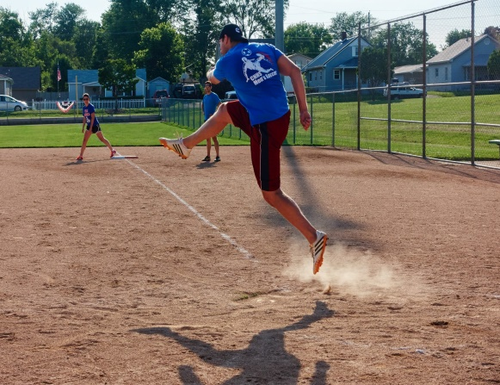 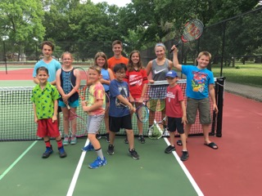

## Athletic Facilities

Athletic Facilities performed standard duties such as sports turf and facility maintenance, irrigation repairs, grounds maintenance, custodial maintenance, equipment maintenance and repairs, ice plant maintenance and repairs, building repairs, electrical and plumbing repairs. They also continued to support all sports programs of the Parks and Recreation Department with set ups and maintenance during events and continued the partnerships with BCSC and other internal groups. In addition, the Athletic Facilities Team welcomed two new hires replacing vacancies in which we were pleased to see how well they fit into our operations.

Major Accomplishments -

* Capital Projects – Continued fence replacement plan throughout the facilities as a part of capital improvements. Repaired drainage in parking lot at Dick Wigh Soccer Complex. Trash enclosures were installed at both Lincoln and Clifty Parks. Replaced some of the bleachers at Lincoln Park Complex. Replaced the overhead doors at Hamilton Center in the Olympia maintenance and storage area. Replaced compressor #3 in the cooling system at Hamilton Center. Due to IDEM requirements, the construction of a new operations building has been approved, which will support proper chemical storage and equipment maintenance.
* Internal Projects/High lights – Renovated two infields on baseball diamonds to alleviate drainage issues interfering with events. As part of our own CIP list, we introduced a more efficient process of spreading our drying agents during tournaments and scheduled programs to help with labor demands. Modified maintenance plans to improve playing conditions throughout Blackwell and Dick Wigh Soccer Complexes with excellent results. Incorporated a web based irrigation controller to Lincoln Softball Complex to help with water conservation and overall management. Relocated several irrigation valves from initial installation in 1998 in order to help with repair issues and the interference with play when valve failures occur. Replaced roof and soffit on the batting cage building at Lincoln Park.

## Columbus Dog Park

Facilities that are dedicated dog parks are great for dogs, their owners and the community. They allow dogs the opportunity to socialize with other dogs and people and provide an excellent source of exercise; especially for dogs whose owners do not have sufficient space for them to run at home. Owners are provided the opportunity to meet dog-oriented people, socialize with other dogs and learn from other dog owners. Since beginning the management of the Dog Park, the Department has invested in many improvements with plans for more in the future.

* Memberships – Memberships have decreased from 84 in 2016 to 69 members with a total of 81 dogs in 2017. All members of the Columbus Dog Park are required to read and sign an acknowledgment that they will follow our dog park rules. These rules help to create a fun and safe environment for both the dogs and their owners.
* Facility Improvements – In August2017,[PetSafe®](http://www.petsafe.net/) announced that 25 cities across the country would receive funds for new off-leash dog park construction and existing park maintenance and upgrades as grant recipients of its 2017 PetSafe® [Bark for Your Park™](http://www.petsafe.net/barkforyourpark/) campaign. Columbus Dog Park was fortunate enough to receive $5,000 in dog park upgrades. The upgrades will be installed in the large dog section spring 2018. Local High School Senior built obstacles for the small dog side of the park for their required senior project.

## Columbus Gymnastics Center

Columbus Gymnastics Center offers many recreational gymnastics programs including classes, open gym times, camps, birthday parties, field trips and special events for children ages 1-15. Partnership programing with Foundation for Youth is very important and has led to Flip and Dip and Boys and Girls Club Fun for Youth nights and open gyms.

* Programs – Management focused on restructuring staff to accommodate larger class sizes in addition to more class offerings. Cheer & Tumble/ ages 7 & Up Open Gym added a second weekly class increasing the number of individuals registered 40% from 2016. The number of individuals participating in open gym remains consistently high, trending almost 10,000 kids each year for the last two years. Programs such as Sensory Open Gym saw an increase of 50% from 2016 which is offered monthly. Both the Gym Buddies and the Sensory Open Gym programs were positively received and were desirable programs which we know will continue to grow throughout the years.
* Community and Partnerships – Housed in the same facility as the Boys and Girls Club, the Gymnastics Center is afforded the unique opportunity to help provide programming to the Boys and Girls Club members. The open gym programs are one of the most popular dual-programming options. The Department is always looking for ways in which we can provide more opportunities to the segments of the population who are underserved. In 2017, the gymnastics center had over 4,000 visits from children in these partnership programs making these programs increasingly popular each year.

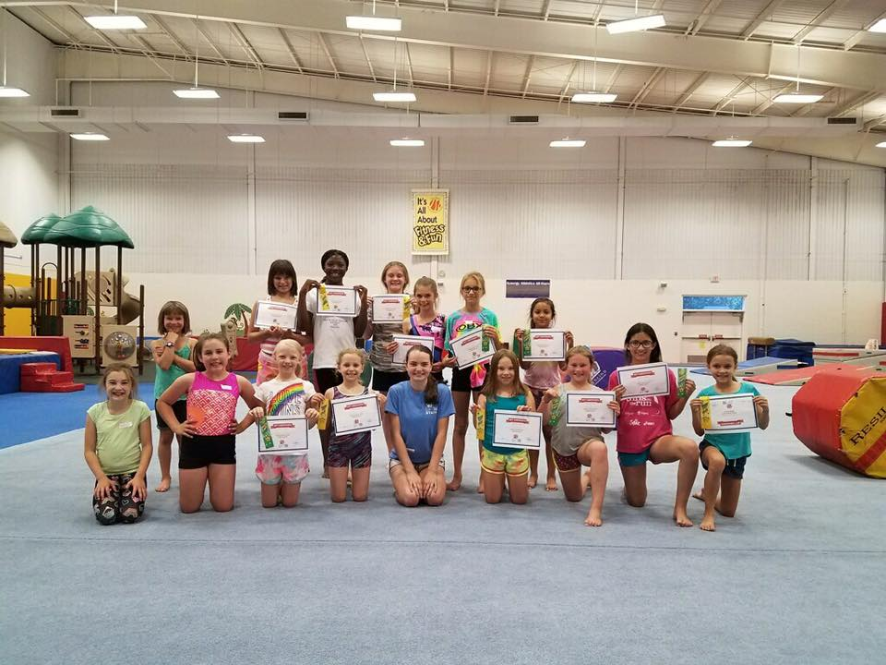 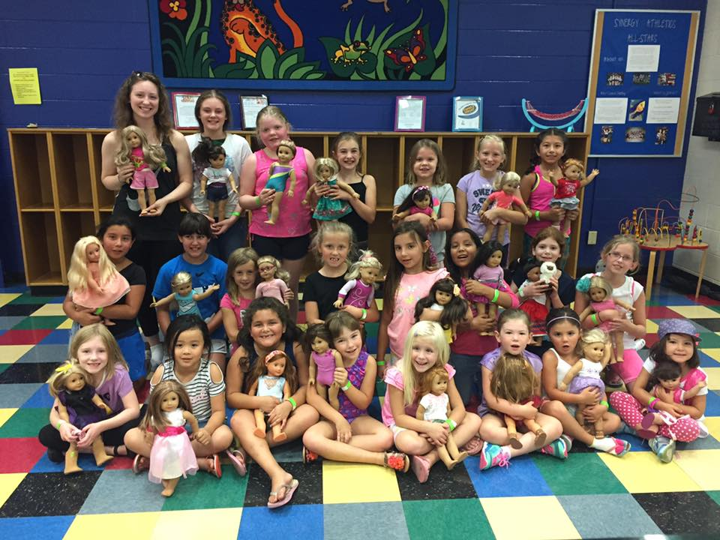

## Donner Aquatic Center

The Donner Aquatic Center season saw a number of successes, particularly due to the favorable weather for aquatics. Donner Aquatic Center is home to public swimming, instructional courses, certification courses, and larger scale aquatics events. Open seasonally, the pool programming is limited in duration, but the outreach of the Aquatics Director stretches further than Donner as there are many partnerships and professional development opportunities led by this area.

* Programs - Public Session attendance totaled 29,071 participants in 2017. Along with public sessions, Donner Aquatic Center also hosted the annual Jaime Miller Swim Meet with Donner Swim Club, 2 Youth Triathlons, CrossFit training Programs, swim lessons, SCUBA lessons and private rentals.
* Partnerships and Community – The Parks Department has established a relationship with many entities in the community, one being the Columbus Fire Department who used the pool to conduct extensive water related training exercises and conditioning. Working closely with Columbus East High School has also opened the door to off-season training, certification courses and programming opportunities. In total, 209 staff and community members took American Red Cross training and were certified in CPR/ First Aid/ AED Training.

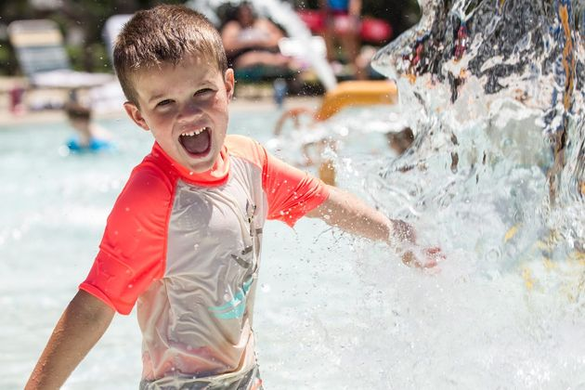 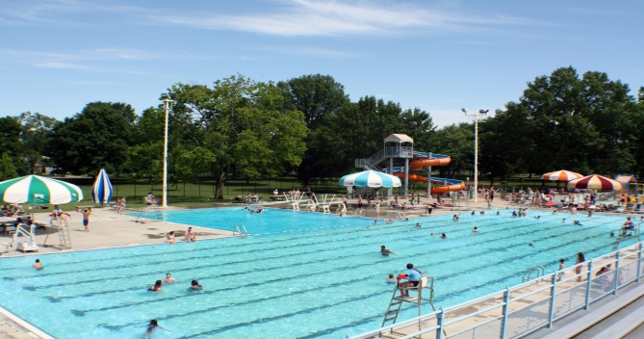

## Golf Courses

Golf successfully completed its second full year of operation under the Parks Department umbrella in 2017! Under the supervision of Golf Pro/Manager, Keith VanDeventer and Greens Superintendent, Aaron Brua, both courses experienced much by way of growth in participation, members and improvement in course conditions. At both Greenbelt and Rocky Ford Par 3, there was a focus on growing memberships, attracting new members, improving course conditions, growing programs for youth, ladies, and beginners, and breaking the mold by implementing new ideas such as Footgolf to the community!

* Programs – The First Tee program grew in participation numbers to 82 from 55, and was the first year in which we had returning players graduate to the next level of the program! This turnout was the highest in the State of Indiana and second in the nation only to Texas who boasts a much higher per capital number than Columbus Indiana. Our Get Golf Ready and Junior Golf Camp programs also both grew in numbers showing an increased interest in both our adult and youth participants. All these programs play a big part in developing the growth and future players in the game of golf. Also added in 2017, the second 9 holes of Footgolf at Par 3.
* Course Conditions – In 2017 golf course conditions improved exponentially at both Greenbelt and Rocky Ford Par 3; earning us high praises with the community and also our members. Small cost effective alterations were made which left large impacts such as improvements to the driving range at Greenbelt, brush removal, mowing practices and different spraying practices. Both rounds of play and memberships increased from 2016 to 2017 and we believe that in addition to the positive environment created by our staff, the course conditions are the biggest precipice for this change.
* Community & External Partnerships – Local businesses have discovered that in addition to Greenbelt, our Rocky Ford Par 3 course is also a fantastic venue for hosting organization team building and fundraising events. With local businesses, churches, local schools (and even the high school from Avon Indiana) coming out to explore Footgolf or regular golf, the courses and the community have both benefited from the growing interest in outings.

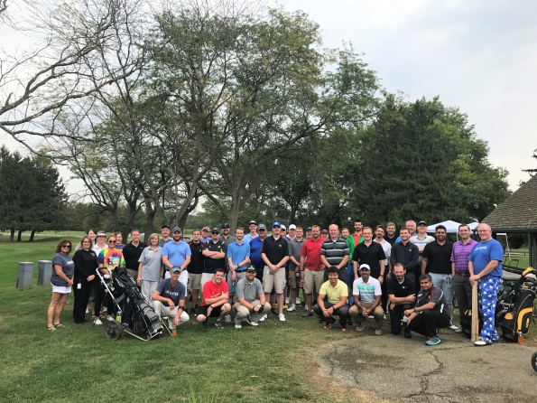 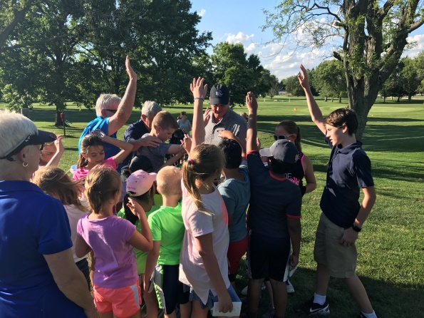

## Hamilton Community Center & Ice Arena

Hamilton Community Center & Ice Arena has continued to make large strides in its programming efforts by increasing the number of users served and programs provided to those both inside and outside of our community. Hamilton also continues to strive to find ways in which it can be more resourceful and efficient with the monies it takes to run an ice arena. The managers associated with Hamilton are often tapped by those throughout the country for best practices in the management of both of the above. The 2017 year was no exception to this rule as they continued to improve on all fronts to provide exceptional service to our community.

* Community & External Partnerships – Hamilton supports a number of user groups which provides a venue to meet the needs of ice sports both in Columbus and from outside of the community. This number of user groups grows each year and for 2017 included: Columbus Youth Hockey, Bloomington Blades Hockey, Total Package Hockey, Lincoln Center Figure Skating Club, Broomball, and Speed skating. Hamilton also helps support the Chuck Wilt Youth scholarship fund by hosting our Turkey Trot annually, which is a 5k walk/run.
* Competitions and Tournaments – Hamilton hosted the Columbus Invitational, three Figure Skating test sessions, a skate clinic and a Basic Skills workshop. In addition, we hosted six hockey tournaments: Fall Foliage, adult and Youth 3 on 3 Hockey, Fuel the Flame, Indy Speed Women’s and Broomball tournaments. These competitions and tournaments help to not only sustain Hamilton but also contribute to the growth of the Columbus economy.
* Programs – Hamilton is always striving to be on the cutting edge with its programs and added two new programs during the 2017 year. These events are most often open to the public and are offered to our community at an affordable cost (sometimes free) to help increase recreational participation. Our programs have been increasing in participation and we are striving to increase these numbers more in the coming year.

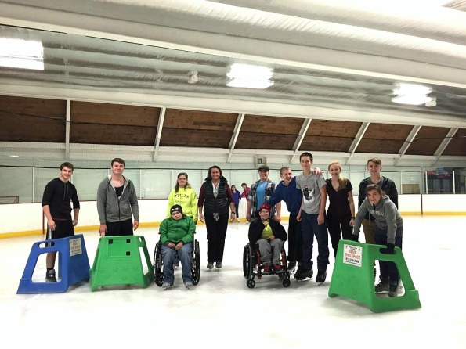 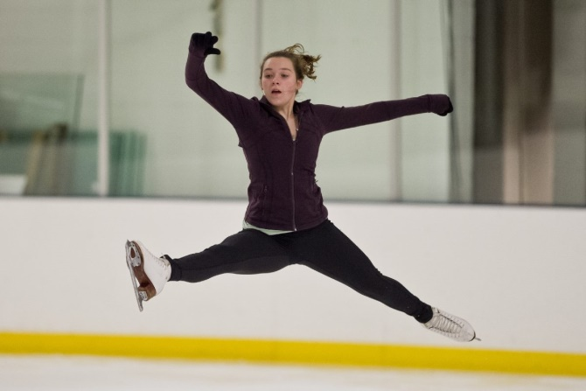

## Park Operations

Public parks contribute to the overall quality of life in our community. Park Operations workers perform normal duties such as landscape maintenance, electrical repairs, plumbing repairs, carpentry repairs, custodial maintenance and vehicle maintenance. With a diverse list of responsibilities, the parks operations division often gets to “wear many hats” as they are routinely tasked with a variety of work orders. They continued to support other areas of the Parks and Recreation Department and Park Foundation with capital projects, labor, supplies and equipment for programing and events. Park Operations likewise supported other City Departments, not-for-profit organizations, and volunteer groups throughout the City of Columbus.

Capital Items – After an extensive bidding process, park operations plans to break ground for the new Lincoln Park Restrooms and Harrison Ridge Playground in the first quarter of 2018. Other Capital Projects included roof and gutter repair to Greenbelt Club House, resurfacing and restriping of parking lots and people trails, and a new basketball court at Harrison Ridge Park.

* Program Support –
  + Parks and Recreation – Easter Egg Hunt, After Prom at Foundation for Youth, Donner Variety shows, Mill Race Rummage Sale and Donner ark 100th Year Celebration.
  + Park Foundation – Tour de Trails events and the Columbus Ninja Warrior competition.
  + Community Organizations –Hospice Concert, Holiday Decorations, Farmer’s Market, and Downtown Flower Pots. These events total over 1,775 labor hours of service to the City of Columbus.

Community Partnerships – Park Operations worked directly with Cummins, Rotary, Eastside Walmart

Volunteer Groups representing over 100 hours of service. Volunteer activities included tree plantings in Donner and Everroad Parks, and trail clean-up. 128 trees were planted in 2017.

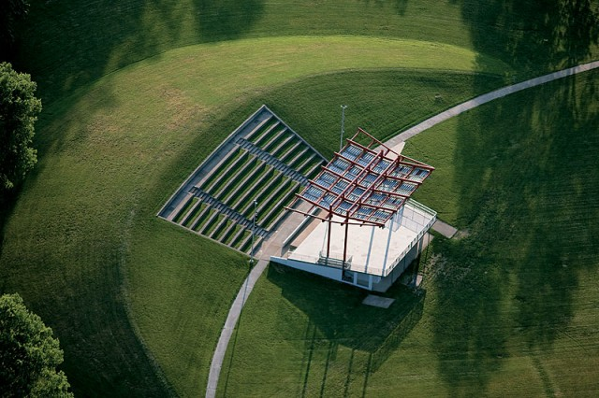 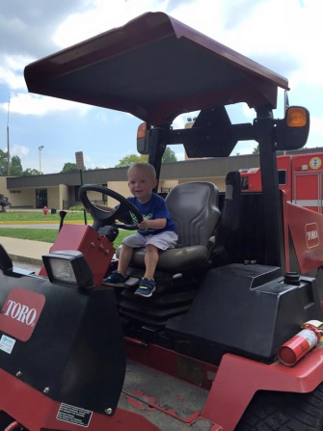 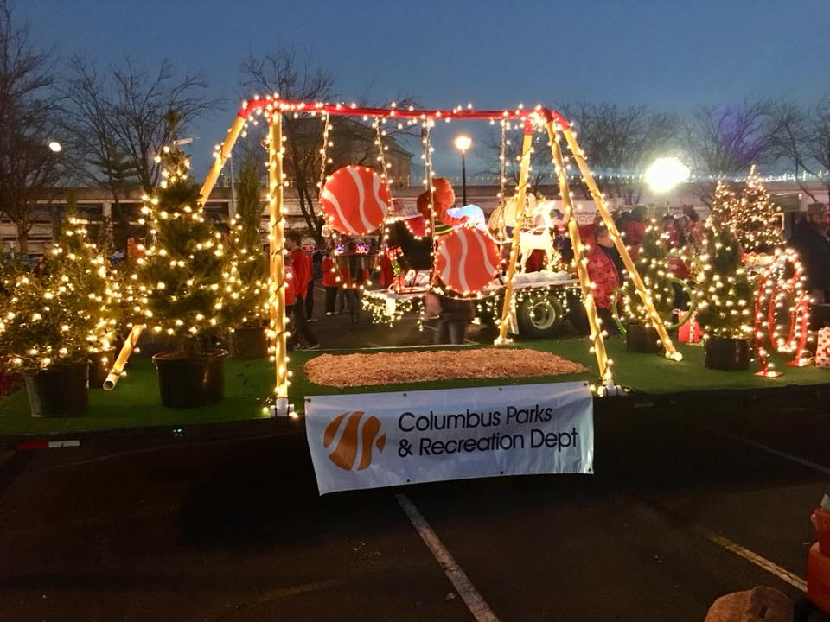

## Recreation & Special Events

Recreation for the Columbus Parks & Recreation Department strives to deliver quality and affordable programs for our citizens which cover a wide spectrum of programs for a variety of ages from pre-school to adults. These programs are a mix of free, low cost and fee-based activities. Free and low cost programs include Festival of the Young Child, Donner Park Variety Shows, Columbus Bluegrass Jamboree Concerts, Noon Kid Concerts, Family Bingo, Let’s Get Ready-Drive-In Movie, Come Out & Play 7 playground program, Free Fun Days, Annual Easter Egg Hunt & Family Nights such as Mad Scientists! and Trick or Treat Tales. Fee based programs include summer recreation day camps, Youth Fishing Derby, adult basket classes, Community Cast-A-Ways Garage Sales, Mill Race Rummage Sale, Holiday Creations Craft Show & Sale, Mom & Me For Tea, Spring Tea for Two and American Girl Doll Day. The Recreation area works with a variety of community partners to present programs. These partners include Columbus Area Arts Council, Lincoln-Central Neighborhood Family Center, Foundation for Youth, Mill Race Theater Company, Ivy Tech of Columbus, Bartholomew Consolidated School Corporation & others.

* Programs - Introduction of new programs including Acting Up! for ages 5-7 and Jr. Mill Race Players for ages 8-12, Spring Tea for Two, Disney Day Camps, Curious Kids Camp, Where the Wild Things Are Camp, Little Laboratory Camp, Winter Wonderland Camp, and two new Fun Day themes; Princess & Pirate Party and Tribute to Dr. Seuss.
* Partnerships and Community - There were 41,913 people who attended a free recreation event or program in 2017. These activities included events and programs sponsored by the Parks and Recreation Department or an event or program held in one of our parks and supported by the Department. Over 60 special events were held in Donner Park, Donner Center or Mill Race Park in 2017.

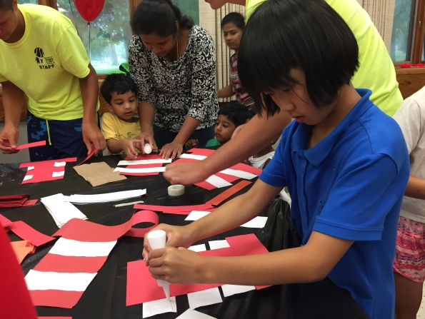 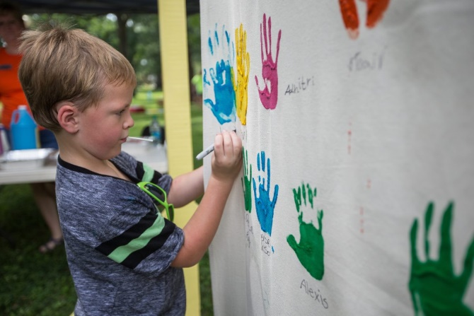

## The Commons

The Commons continued to serve the community as a gathering place and tourist destination in the center of the Columbus, IN Arts & Entertainment District.  Guests visited The Commons to explore the James A. Henderson indoor playground, Jean Tinguely’s *Chaos I* sculpture, attend events in the Nugent-Custer Performance Hall and experienced our 4 dining options.  Our maintenance staff did an outstanding job maintaining the cleanliness and upkeep of the building while assisting with the setup needs of 213 rental events this year.  And additional 526 meetings took place in our 2 conference rooms designated for local not-for profit use.  The Commons front office staff oversaw general inquiries, event coordination and communication with staff and partners regarding upcoming events both in and surrounding The Commons.

* Welcomed Luciana’s Mexican Restaurant & Cantina in September and the new owner of Puccini’s/Bucceto’s Pizza in October!
* Repair & maintenance work was done on the wooden dance floor in the Performance Hall, to the frames & screens on the Evapco cooling tower, the Washington Street bollards that were damaged.  We also moved ahead with an approved RFQ to move ahead with public input & design study of the playground area and upgrades to the A/V projector, screen and digital connections in the Performance Hall.
* Participated in Exhibit Columbus as a location for one of the *Pause* Bench displays and other arts and architecturally focused programming by partnering with organizations like Columbus Museum of Art & Design, Columbus Area Arts Council and others.

## The Columbus Park Foundation

The Columbus Park Foundation focused on assisting the Columbus Parks & Recreation Department in providing volunteers and monetary assistance for projects not covered and addressed in the normal budget. Their Tour de Trails Run/Walk and Tour de Trails Bike Challenge fundraising events raised funds for People Trail maintenance and unrestricted funds. The Chuck Wilt Youth Scholarship Fund allowed children 191 children from 94 families, who otherwise could not participate, to sign up for 290 Parks and Recreation programs. The Park Foundation received a total of $43,606 in donations including $12,500 from Toyota Industrial Equipment and $20,000 from Mill race Marathon on behalf of Columbus Running Club. The Columbus Park Foundation also supported the Come Out & Play playground program at 9th Street, Morningside and Pence Street Parks through the Race2Play, Come out & Grow, and Curiosity Machine Programs.

* Trees – Due to the Emerald Ash Borer infestation, planting trees is more important than ever.  With the help of the James K. Baker Tree Fund, we were able to expand and replace over 128 trees in our parks.  In commemoration of Toyota Industrial Equipment’s 50th anniversary, they donated 50 Cherry Blossom trees.  The trees were planted along Rocky Ford Par 3 Golf Course and the new Safe Routes to Schools trail.
* Program Support
  + Parks and Recreation – Chuck Wilt Scholarships, Race2Play, Come out & Grow, and Curiosity Machine
  + Community Organizations - Arbor Day Tree Planting, United Way Day of Service and Day of Caring, Youth Services, Rotary Club and Fall Tree Planting. These programs totaled over 125 (1,846.50 labor hours) from Volunteer organizations.
* Jolie Crider Memorial Skatepark - The Jolie Crider Memorial Skatepark was built in 1999, and is in need of a complete renovation. The Columbus Parks and Recreation Department, in collaboration with Columbus Park Foundation, is making a transition from a wooden skatepark to a more sustainable concrete material. Renovating the skatepark will provide an architecturally aesthetic, safe place for skateboarders, all while continuing to provide a memorial to Jolie Crider and her legacy. The new design will be completed by Finnish pro-skateboarder turned landscape architect, Janne Saario. The build and construction will be completed by Bloomington, Indiana based Hunger Skateparks. $190,000 of the $385,000 is still needed to complete the design and build of the new 12,000 square foot concrete skatepark. The new design will be completed by Finnish pro-skateboarder turned landscape architect, Janne Saario. The build and construction will be completed by Bloomington, Indiana based Hunger Skateparks.
* Community Partnerships - Volunteers from Bartholomew Co. Youth Services, Walmart East, Cummins, Inc., Faurecia, and others spent almost 1,077 hours cleaning & maintaining 11 segments of the People Trail; saving Columbus nearly $24,846.

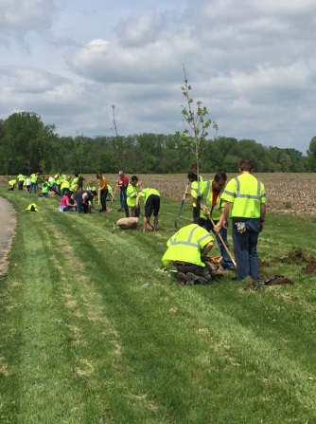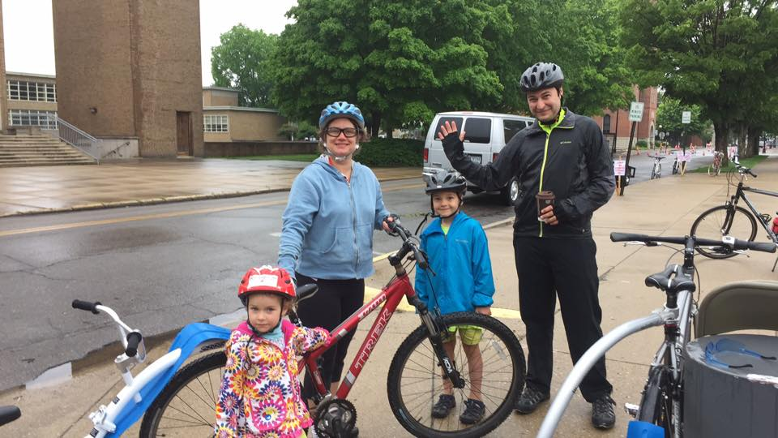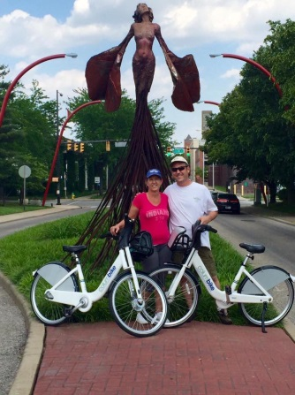

# Current Projects

* **Trail Improvements –**  The Haw Creek Trail re-route saw old Newbern Bridge placed across Clifty Creek, just south of 25th Street, allowing trail users to safely pass under 25th Street bridge, avoiding dangerous traffic.  This extension now makes it possible to travel the People Trail system from Columbus Airport to downtown.  The trail officially re-opened February 1, 2018.
* **Capital** - The Parks and Recreation Department was able to complete 26 capital projects in 2017 with $1,095,000 from City Capital and $236,000 from Parks and Recreation General Fund reserves capital.

# 

# Goals for Fiscal Year 2018

Ultimately, the goal of Columbus Parks and Recreation Department is to build community in Columbus and Bartholomew County through enriching the lives of those who live, work, and play here. During 2018, the Department intends to meet the following goals:

* **Recreation** – Continuing to grow programming opportunities by adding 11 new family, adult and youth recreation programs.
* **Sports** –
* We are looking to diversify our programs by adding an additional youth sport option, Youth Non-Contact Rugby! This sport is rising in trends across the US as our national teams gain more exposure and we want to stay on the cutting edge of the trend!
* For adults, we are looking to provide our first Pickleball Tournament in partnership with the Columbus Pickleball Club! The tournament will be a fundraiser for the future expansion of courts within the Parks Department and will take place in September!
* Our sports department is also exploring options to add a Cricket pitch on the East side of Columbus through a possible partnership with CICC.
* **Golf** – We are looking to continue to increase our rounds played at both Greenbelt and Rocky Ford Par 3 golf courses in addition to adding a new Wednesday night league at Greenbelt.
* **Hamilton Community Center & Ice Arena** - Continuing to grow programming with three new classes; Speedskating, Theater of on Ice and a Girls Only Hockey class.
* **Maintenance** - In order to ensure quality grounds, structures, facilities and capital asset preservation, Park Operations will be evaluating maintenance plans and establishing a full Department inventory.

# Budget and Financials

## 2017 Budget

Columbus Parks and Recreation utilizes three funds (Parks General Fund, Parks Non-reverting, & Commons Non-reverting) in order to run over 595 adult and youth organized classes and programs and maintain approximately 1,000 acres of land, 23 parks, 5 large facilities and multiple small facilities comprising of more than 200,000 square feet under roof, and over 20 miles of trails.

The 2017 Parks General Fund budget was $4,640,626. These funds are derived primarily from tax dollars (property tax, excise tax, financial institution tax and commercial vehicle excise tax). They are invested in salaries, services, supplies and maintenance of the Parks and Recreation system comprised of approximately $100,000,000 of assets.

The 2017 Parks Non-reverting appropriation was $2,652,427. Unlike the Parks General Fund, which is financed through city tax revenue, this fund is financed from revenue collected from user fees. Examples of user fees include: ice rink admissions and concessions, facility rentals, golf fees, and program and class registrations.

The 2017 Commons Non-reverting budget was $1,477,274. This fund is solely responsible for the operations and upkeep of the Commons facility. This fund is partially funded from an economic development income tax distribution from city tax revenue. Any money left in this fund at the end of each year remains and will be used for future capital and operational needs of The Commons to lessen the burden to the taxpayers of Columbus.

For 2017 we appropriated $240,000 out of our general fund cash reserves to invest in capital needs and encumbered from 2016 $177,459 for capital projects. We returned $304,635 to our Parks general fund cash reserves. We returned $43,614 to our Parks Non-reverting fund and $14,224 to the Commons Non-reverting fund cash reserves.

## 2017 Capital Spending

# Financials

## Parks General Fund

|  |  |  |  |  |  |  |
| --- | --- | --- | --- | --- | --- | --- |
| **General Fund** | **2016 Budget** | **2016 Actual** | **2016 % Spent** | **2017 Budget** | **2017 Actual** | **2017 % Spent** |
| Personal Services | $2,784,772 | $2,685,254 | 96% | $2,941,524 | $2,690,283 | 91% |
| Supplies | $387,953 | $377,084 | 97% | $398,564 | $361,102 | 91% |
| Other Services & Charges | $740,112 | $660,462 | 89% | $875,579 | $741,792 | 85% |
| Capital Outlays | $911,574 | $727,906 | 80% | $424,959 | $184,362 | 43% |
| **Total** | **$4,824,411** | **$4,450,706** | **92%** | **$4,640,626** | **$3,977,538** | **86%** |

## Parks Non-Reverting Fund

|  |  |  |  |  |  |  |
| --- | --- | --- | --- | --- | --- | --- |
| **Non-Reverting Fund** | **2016 Budget** | **2016 Actual** | **2016 % Spent** | **2017 Budget** | **2017  Actual** | **2017 % Spent** |
| Personal Services | $869,181 | $861,430 | 94% | $964,112 | $857,360 | 89% |
| Supplies | $407,950 | $400,744 | 98% | $421,160 | $430,034 | 102% |
| Other Services & Charges | $1,220,420 | $1,218,179 | 100% | $1,260,655 | $1,217,837 | 97% |
| **Total** | **2,506,051** | **$2,442,120** | **97%** | **2,652,427** | **$2,505,231** | **94%** |

## The Commons Fund

|  |  |  |  |  |  |  |
| --- | --- | --- | --- | --- | --- | --- |
| **The Commons Fund** | **2016 Budget** | **2016 Actual** | **2016 % Spent** | **2017 Budget** | **2017 Actual** | **2017 % Spent** |
| Personal Services | $472,202 | $467,062 | 99% | $504,673 | $495,855 | 98% |
| Supplies | $42,650 | $21,629 | 51% | $42,650 | $22,942 | 54% |
| Other Services & Charges | $394,750 | $352,422 | 89% | $429,951 | $379,544 | 88% |
| **Total** | **$909,602** | **$841,133** | **92%** | **$1,477,274** | **$936,047** | **63%** |

# Addendum

## Athletics

External organizations who utilize our facilities (BCSC, Columbus Express Soccer, Columbus Softball Association, etc.)

Adult and youth recreational sports programs offered through the department (baseball, softball, soccer, tennis, etc.)

Baseball and softball tournaments held at Clifty Park and Lincoln Park.

Soccer, rugby and lacrosse tournaments held at and Blackwell/Dick Wigh Soccer Complex.

## Columbus Gymnastics Center

Includes all classes in addition to camps and special programs such as Drop N Shop, Olympics, Super Stars and field trips.

Sessions include classes such as Gym Buddies, tumbling, cheer and more advanced gymnastics classes.

## Donner Aquatic Center

Includes programs such as the youth triathlon, swimming lessons, bike camps, lifeguarding classes/certifications, and private lessons.

Note: Preschool class maximums were lowered from 30 to 20 participants beginning in 2015 so as to offer a superior educational experience.

Includes programs such as Doggie Swim, the triathlon class, evening swims, season pass attendance, etc.

Total number of participants from all programs, drop-ins and lessons.

## Golf Courses

Includes both 9 and 18 holes of golf and footgolf played at Rocky Ford Par 3 Golf Course. Note: There is no comparative data for 2015 as the course was managed by a private individual.

Includes both 9 and 18 holes of golf played at Greenbelt Golf Course. Note: There is no comparative data for 2015 as the course was managed by a private individual.

Includes the Men’s, Women’s, Senior’s, and Choose Up’s leagues. Note: There is no comparative data for 2015 as the course was managed by a private individual.

Includes The First Tee, Jr Golf Camp, and Get Golf Ready classes. Note: There is no comparative data for 2015 as the course was managed by a private individual.

## Hamilton Community Center & Ice Arena

Programs include all levels of hockey, specialty camps, public programs, tournaments, etc.

Includes classes such as skating and hockey and synchro skating.

Includes all programs, drop-ins, sessions and public events.

Includes activities such as public events, speedskating, figure skating, hockey, public skate sessions, etc.

## Recreation and Special Events

Includes activities such as kids concerts, variety show, jamborees, drive in movies, Easter egg hunts, Come Out and Play, etc.

Includes programs such as camps, Kids in Motion, theater/acting, Variety Day and other field trips, etc.

Includes the total number of participants, events, and rentals.

Includes the total number of people who attended a rental (free/cost) at a Parks Department facility and/or park.

## The Commons

Total number of events by type of rental.

Includes the total number of estimated guests for private, free and ticketed events and rentals.

Includes the total number of rentals by room per year.